**Heroes Of Pymoli Game: Data Analysis**

Three observable trends arising from the analysis were as follows:

1. **Gender Analysis: Significantly More Male Players than Female Players**

This game attracted approximately 6 times as many male players as it did female players. This observation was further confirmed by the purchasing outcomes where the number of purchases and the total value of purchases were 5.5 and 5.7 times greater respectively for males than they were for females. (See below):

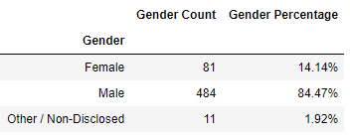

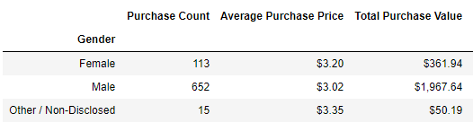

1. **Game Polularity Analysis: A popular game item does not always translate into a corresponding profitable game item.**

While the outcomes below suggest a likely correlation between item popularity and profits, a closer analysis shows that the popularity of some items are not reflected with comparative profits for those same items.

**Top 5 Most Popular game items:**

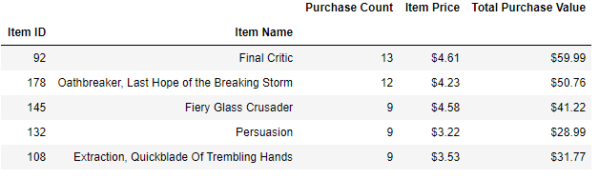

**Top 5 Most Profitable game items:**

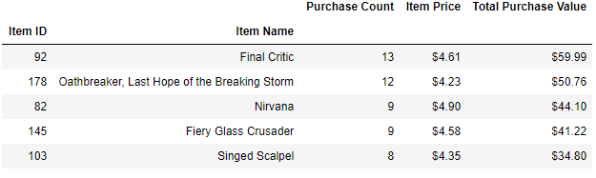

1. **Age Range Analysis: 20-24 year olds prove to be a very strong economic driver.**

Of the 8 age group ranges analyzed, one age group (one eighth), the 20 -24 year olds contributed to just over 41% of item revenue for the game.



